The Little Inn

**Vision:**

* To stay there for longer and/or
* To eat at the Inn more often

**Our Vision**: We wish to create a software which will help Mr. Brown have his guests visit more frequently and for longer periods of time. We also wish to increase the flow of guests through the restaurant.

**Actors:**

The servant - Serves and can cook.

The Chef - Can only cook.

Mr. Brown - Supervises, Can serve and cook.

Mrs. Brown - Takes care of B&B rooms, (can control Mr. Brown).

**Exercise 1:**

Line up requests for the software;

1.   Display working hours for staff (Mr. Brown, cook, servant and Mrs. Brown)

2.   Commodity storage (Mr and Mrs. Brown, the servant and chef)

3 Room reservations (Mr and Mrs. Brown)

4 Meal orders (Chef, servant and Mr. Brown)

5.   Recipes (Chef, Servant and Mr. Brown)

Mr. and Mrs. Brown request that the software will further develop the Little Inn. They want the software to increase the time customers stay at the Inn and increase the flow of customers through the dining room.

**Exercise 2:**

Set up all use cases (brief versions) so every user expectation including the requests are covered

**Workforce management:** This use case will cover the basic needs for Mr. Brown to administer the hours his employees work. The employees will be able to see which days they will work and at what time their shift start and end. Mr. Brown will be able to use this information to manage wages for the staff.

**Commodity:** This use case should keep track of The Inn’s storage. It will be split into categories of: Restaurant and Bed and Breakfast. The items will be listed so the viewer will be able to see when they were purchased, their expiration date and the amount that is in stock. Keeping track of stock can help improve the quality of the restaurant and contribute to more people using the restaurant.

**Room reservations:** This use case will explain when rooms are available for the customers. Following info will be necessary: Arrival date and time, departure date and time, guest info (first name, last name, date of birth and ID), payment information and special needs.

**Table reservations:** This use case will give the guests the opportunity to check for availability and book a table in the restaurant. The restaurants  menu will be listed with prices and ingredients.

**Meal orders:** This use case will demonstrate how the servant and Mr. Brown will be able to place meal orders directly to the chef. Following will be included, table number, amount of guests, type of dish and allergies.

**Recipes:** This use case will give the staff the possibility of sharing the different recipes that are used for cooking. The recipes will be detailed and include ingredients and course of action.

**Guest history:**  This use case will create an overview over the guest’s booking history and possible preferences. Mr. Brown will be able to use this to give special offers to guests so they can reconsider visiting once again.

Exercise 3: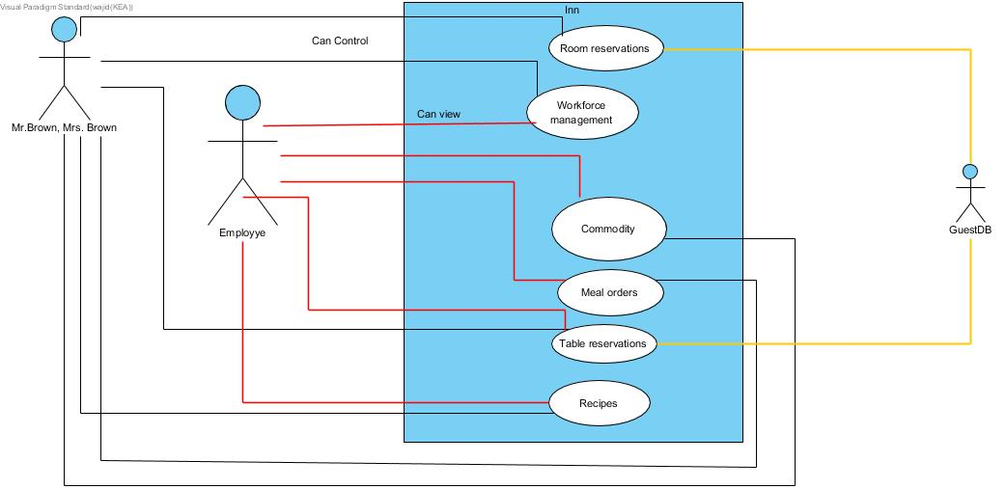

Exercise 4:

This domain model shows how the software under design will give guests the ability to book a room.

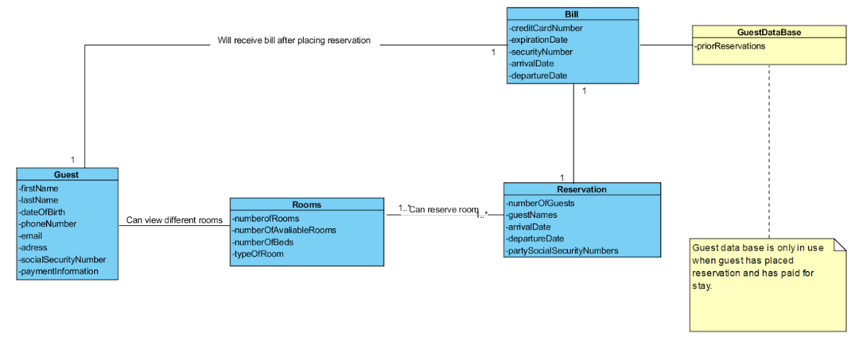

Exercise 5:

This domain models shows the software connected to shift management.

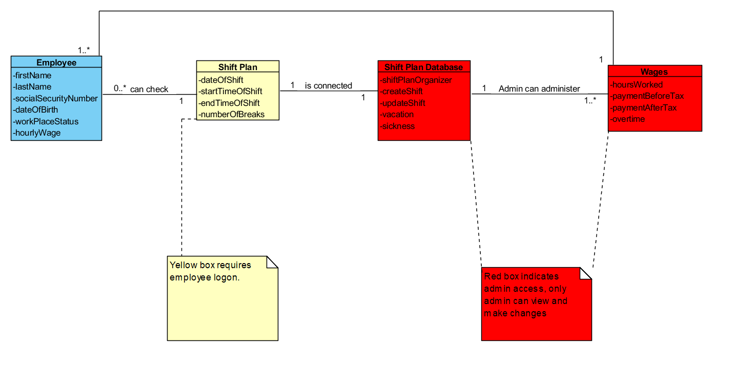

|  |  |
| --- | --- |
| Use Case Name | Workforce management |
| Scope | Administration and employees |
| Level | Administrate working hours |
| Primary Actors | Mr. Brown |
| Stakeholders | Mr. Brown: Needs an overview of his employees shifts and hours. This will ensure he can pay his employees.  Employees: Will want to view their shifts and ensure they are paid correctly. |
| Preconditions | Mr. Brown is validated by login, and organizes shift plan.  Employees are validated by personal login and can view their shifts. |
| Succes guarantee | For the system to be successful Mr. Brown must ensure his employees shifts are updated and viewable. |
| Main success scenario | 1. Admin login is validated 2. Admin creates a new shift 3. Admin chooses employee 4. Admin chooses start date and time 5. Admin chooses end date and time 6. System presents shift length and wage amount 7. Admin accepts shift 8. Shift is published to software |
| Extension | 1a. If admin login is wrong system will inform admin “Incorrect username or password, please try again”.  4a - 5a. If admin chooses a date where the establishment is closed the system will inform user.  4b - 6b. if admin chooses a time where the establishment is closed the system will inform user.  7a. If admin forgets to accept shift system will pop up warning sign to indicate that action is missing. |
| Miscellaneous | If the employee doesn't show up for his/her shift.  it's an issue if the software crashes. |